Description
22U network rack enclosures stand out as the preferred choice for floor installations, boasting a robust structure capable of supporting static loads of up to 1700 lbs.
Heavy-duty casters are included to ensure easy and flexible movement. Optional adjustable leveling feet are available to enhance stability and fixation. The quick-open side panels enhance installation and maintenance efficiency, facilitating seamless access to your equipment.
Choose from multiple sizes to accommodate varying equipment space requirements, with the option for customization to meet specific needs.

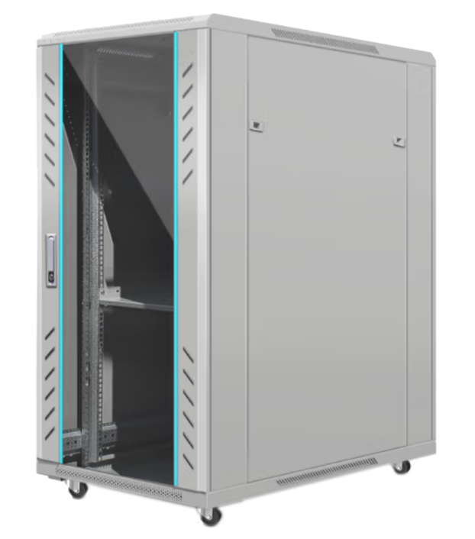

Features
- Both top and bottom cable entries enhance installation flexibility, accommodating various cable configurations.
- Can be shipped disassembled, reducing transportation and storage costs for added efficiency.
- Offers multiple front and rear door styles (optional), providing customization options to suit specific needs.

General Specification
Material High Quality SPCC
Material Thickness Rails 2 mm, Other 1-1.2 mm
Finish Power Coating
Color RAL7035, Gray
Width 600 mm
Depth 600 mm
Height 22U
Rack Mount 19”
Access Front Door/Rear Door/Side Panels
Locking Mechanism Single Point Locking
Static Loading Capacity 800 kgs/1700 lbs.
Included Accessories 4xCasters, Grounding kits, M6 Screws & Nuts, Keys
Optional Accessories Fans, Shelves, PDU, Blank Panels

Ordering Information
Part No. | Description
NSJ6622BP1 | 22U Network Rack Cabinet, 600x600mm, Standard Glass Front Door, Solid Metal Rear Door, Gray

